Plan for Final Presentation

1. Introduction
   1. Dynamic framework? Might not be relevant
   2. History of our understanding the “resting” mind vs the on-task mind.
2. Data Collection Methods
   1. EEG – brief explanation of what it measures
   2. Thought sampling during an activity where participants were asked to choose left or right arrows
   3. Distinguished between event-related potentials and windows of variability with ongoing thoughts
3. Data format: (confirm these numbers)
   1. Binary classification with up to 34 features.
   2. 20 ? participants for a total of 768 samples
4. Our results
   1. Features we chose?
      1. Visual – Bar graph showing correlation with label? A graph with blue lines

         Description automatically generated
   2. Model we chose and why we think it is a good fit for this scenario.
   3. Hyperparameter tuning?
      1. Visual - Performance of train vs test set over various hyperparameter values   
         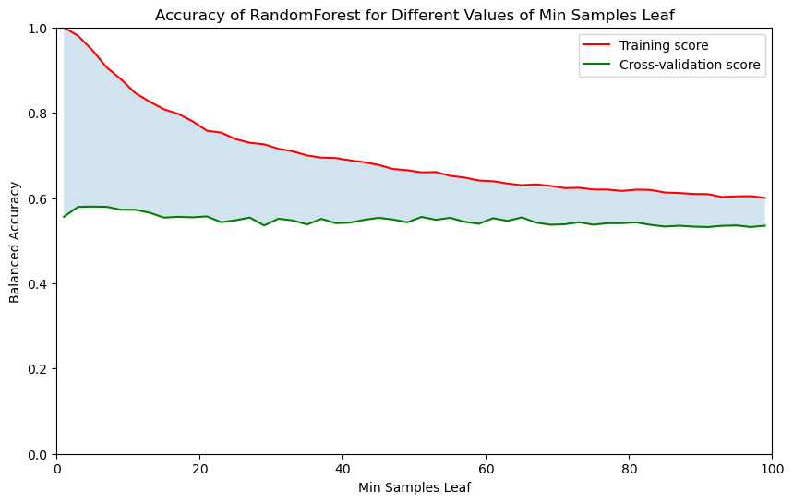
      2. Comments on the best hyperparameters?

rf_params = {

    'bootstrap': True,

    'max_depth': 19,

    'max_features': 'log2',

    'max_samples': 0.7,

    'min_samples_leaf': 2,

    'min_samples_split': 2,

    'n_estimators': 100

}

* 1. Best results (Matlab’s results)
     1. Matthew’s correlation coefficient
     2. Balanced accuracy
     3. AUC 🡪 plot a graph?
     4. Confusion matrix 🡪 visual

1. Conclusions, and future directions
   1. More data would be ideal
   2. ??